GOVT.COLLEGE OF NURSING, G.S.V.M MEDICAL COLLEGE CAMPUS, KANPUR
REPORT ON: WORLD CANCER DAY- 09.02.24

World Cancer Day held on 4 February every year, it is a leading global awareness day and this initiative has led by the Union for International Cancer Control (UICC).
Cancer is a metastatic condition in which the cells initiates to multiply at an absurd manner, this condition usually led to the multiple myths and taboos among people in the community. On 09.02.2024, event of the World Cancer Day the guest lecture been organized of Major Dr. M.Q. Baig, Professor Radiation Oncologist and Clinical oncologist, J.K Cancer Institute, Kanpur in the Govt. College of Nursing, GSVM Medical College Campus, Kanpur, under the supervision and guidance of Ranjna Singh Rajpoot, Assistant Professor, College of Nursing, GSVM Medical College Campus, Kanpur.
The program commenced at 12 noon with Saraswati Pooja and floral welcome of the guest Major Dr. M. Q Baig, Professor Radiation Oncologist and Clinical oncologist, J. K. Cancer Institute, Kanpur done by the Lt. Col. Dr. Karesh Prasad, Principal, College of Nursing, GSVM Medical College Campus, Kanpur and the floral welcome of Lt. Col. Dr. Karesh Prasad, Principal, Govt. College of Nursing, Kanpur done by the Assistant Professor, Javed Ansari. Afterwards, the lecture began by our guest lecturer Major Dr. M.Q Baig, Professor Radiation Oncologist and Clinical oncologist, regarding the cervical cancer. He initiated his lecture with the introduction and further he explained about the cervical cancer, which is the third most common cancer in women worldwide. It gradually shows up as precancerous condition and being called as dysplasia, which is detected by routine Pap Smear and is completely treatable. Then, he explained about the etiological factors such as Human papillomavirus (HPV), multiple sexual partners, early age sexual relationship. Various risk factors been also enumerated such as smoking, weak immunity, family history and certain signs and symptoms appears like bleeding between regular menstrual periods, bleeding after sexual intercourse, douching or pelvic examination, or increased vaginal discharge and pelvic pain. Then, he described the diagnostic tests done to diagnose or as a confirmatory test such as PAP smear test, HPV DNA test, colposcopy, cone biopsy, chest x-ray, computed tomography(CT), magnetic resonance imaging(MRI), pelvic ultrasound, also he enlisted the stages of the cervical cancer stage I, stage II, stage III, stage IV, followed by the managements, chemotherapy, radiotherapy, surgical management like laser surgery, loop electrosurgical excision procedure (LEEP), cryosurgery, hysterectomy. Furthermore, nursing management involved dietary management, preventive measures and follow up for the patients was included.
After the lecture ended, the World Cancer Day theme explained by Ms. Shreya Tiwari, student of M. Sc. Nursing I year, the theme is “Close the Care Gap”, which highlights that everyone deserves access to healthy cancer care and most importantly to reduce the taboos and myths regarding the cancer and change the behavioral pattern towards cancer patients without discriminating them.
At the end of the program, vote of thanks been rendered by Ms. Shashi, student of B.Sc. Nursing II Semester, II year. And afterwards the event was ended with fruitful success.

GLIMPSE OF THE EVENT
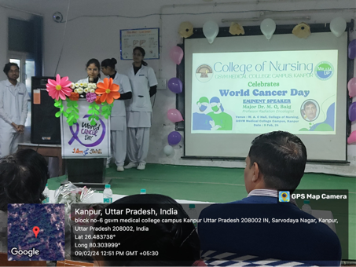
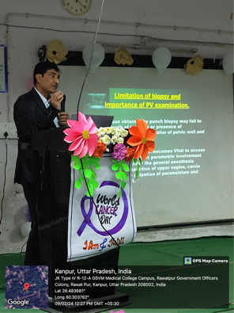
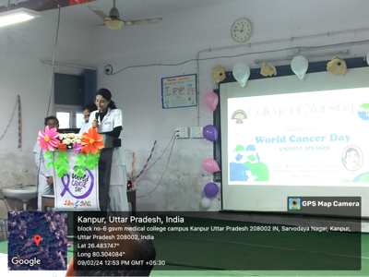
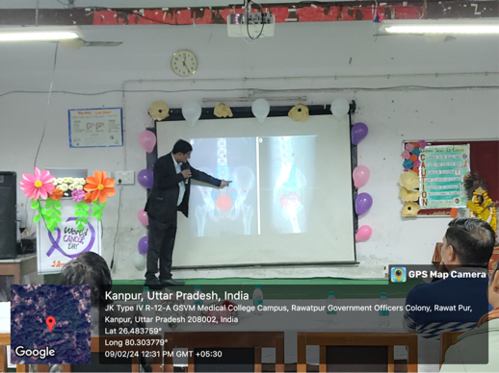
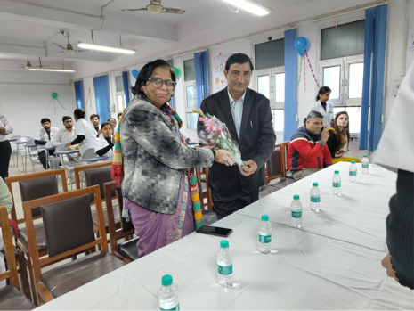
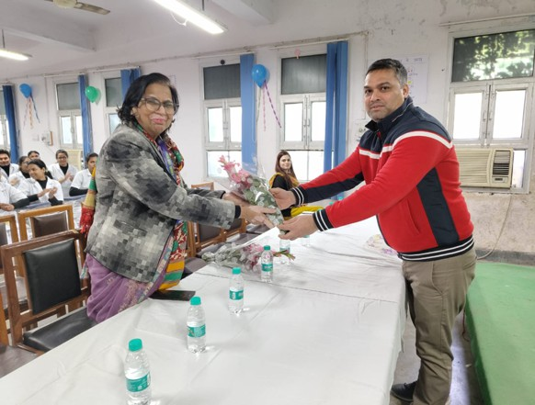

Health Education By M.Sc. Nursing Ist Students in J K Cancer Institute Kanpur on 07/02/24.

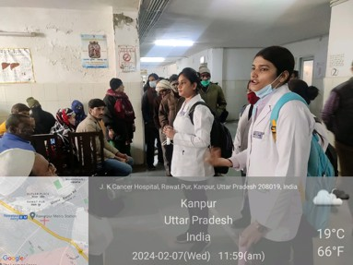
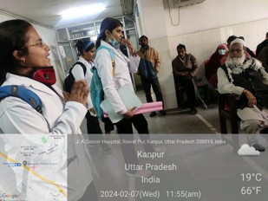
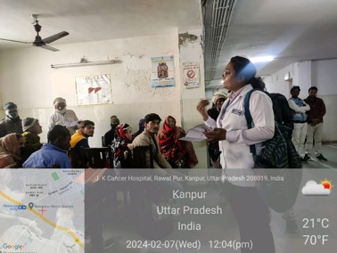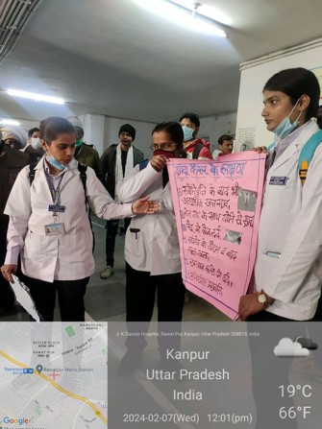

Prepared By Principal
Mrs. Ranjna Singh Rajpoot College of Nursing, Kanpur
Assistant Professor

